The purpose of this ActionSheet is to reinforce what you learn about employee engagement. This ActionSheet accompanies the live or recorded webinar, “Employee Engagement in Action.” Print or take notes electronically.

Engagement Can Help Focus
Employee engagement provides a powerful set of _______________ that can help you face the pressures of being a supervisor.

Employee Engagement Cycle

I:

(i.e. what is going well and what could be better?)

D:

(i.e. which issues are the most important to address given our goals and priorities?)

A:

(i.e. what specific, concrete steps are we going to take to improve?)

Where are we now?

Over the past 5 years, we’ve seen three major trends in engagement work:

Faculty and staff are highly _______________ to having a positive impact through our work.

When action is taken to address issues that come up in the engagement survey things _______________.

There are still a lot of faculty and staff who are _______________ with their work environment.

How do I know how we’re doing?
How do you address employee engagement if you didn’t receive a survey report? Check all that apply:
Have conversations with your team or department.
Use discussion guides from the Supervisory Development Course Module 5.
Review the 2017 engagement report for your college, campus, or unit.

What do frustrated people do?
What 3 actions do frustrated people usually take?

Top frustration sources
University faculty and staff say the three most common sources of frustration are:

Key component of Employee Engagement
A key component of employee engagement for successful supervisors is listening and
acting on _______________.

Scenario: Meet Anders
Notes:

Poll Question – How do you react to feedback?
What do you do when you get your survey results or just feedback in general? (Select all that apply)
- Ignore it
- Procrastinate doing anything about it
- Ask questions to understand more about the feedback
- Jump to conclusions and want to ”fix” everything
- Celebrate what’s going well (strengths)
- Other (please share in the chat)

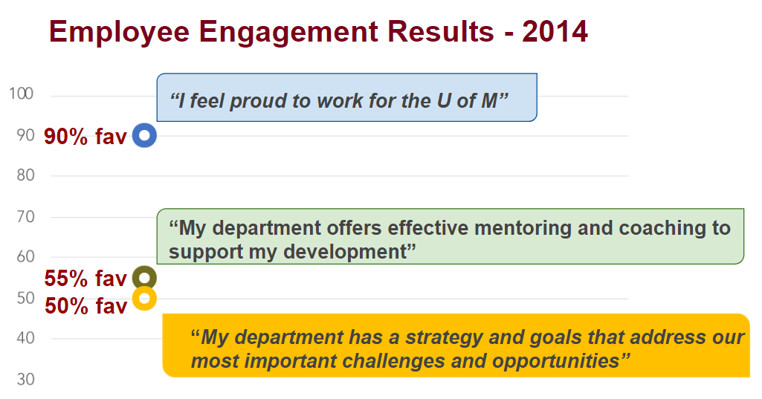
Employee Engagement Results - 2014
Notes:

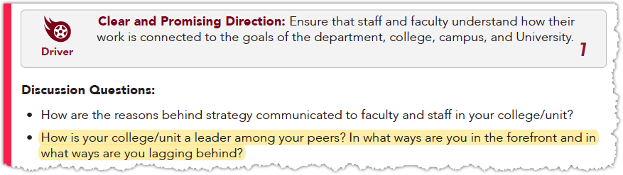
Resources for discussion
The Quick Guide to Employee Engagement Drivers and Discussion Questions is a useful tool to guide your discussions about engagement.
How is your college/unit a leader among your peers? In what ways are you in the forefront and in what ways are you lagging behind?

Poll – What is the result of Anders’ action?
With the action Anders is taking, what’s your prediction for the results of these two items in the 2015 survey?

Item 1: “My department has a strategy and goals that address our most important challenges and opportunities”
- Increase in favorability
- Decrease in favorability
- Stay the same
Item 2: “My department offers effective mentoring and coaching to support my development”
- Increase in favorability
- Decrease in favorability
- Stay the same

Employee Engagement Results
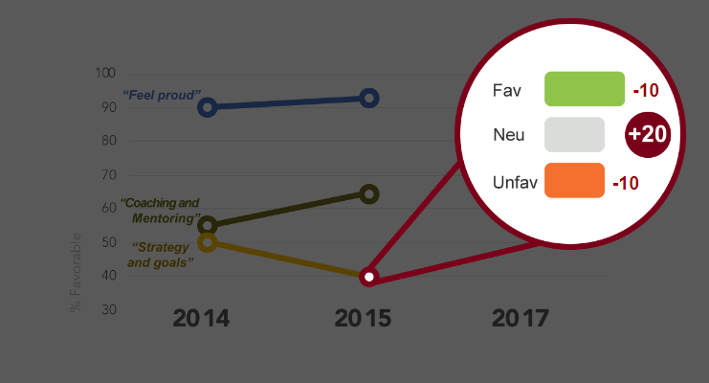
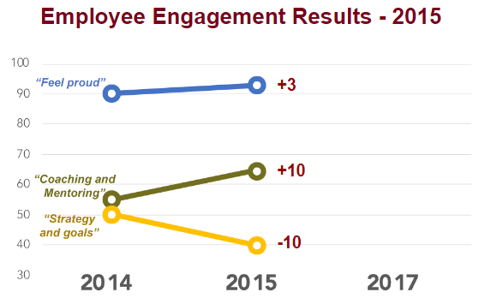

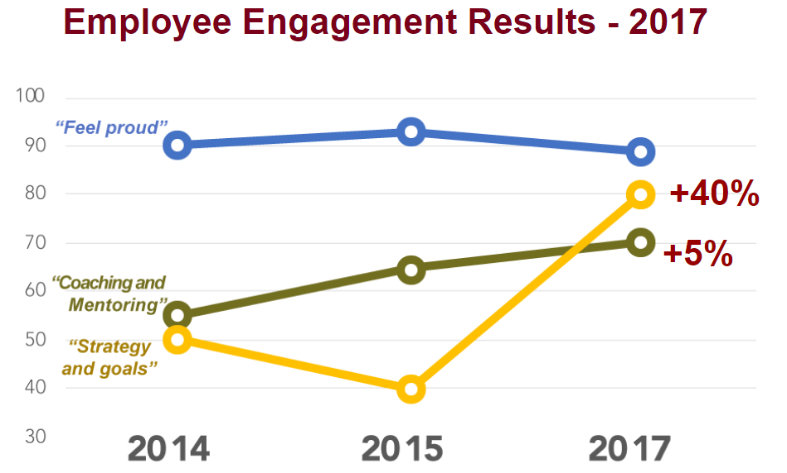
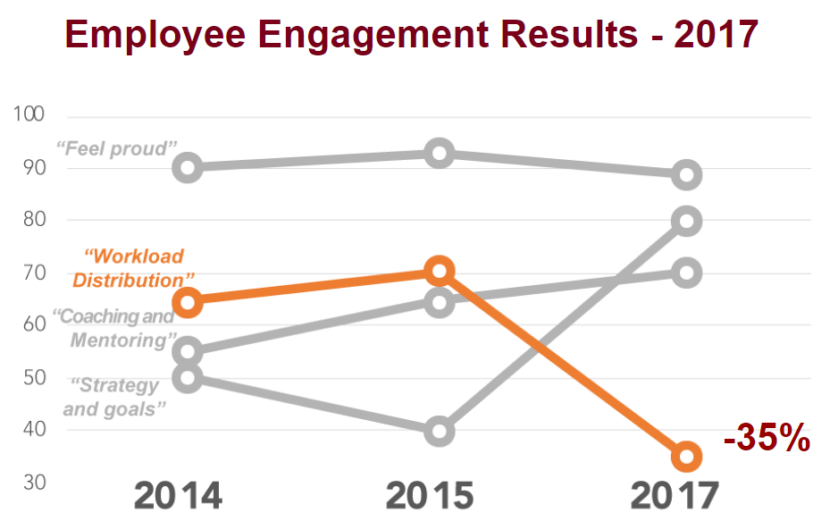

Notes:

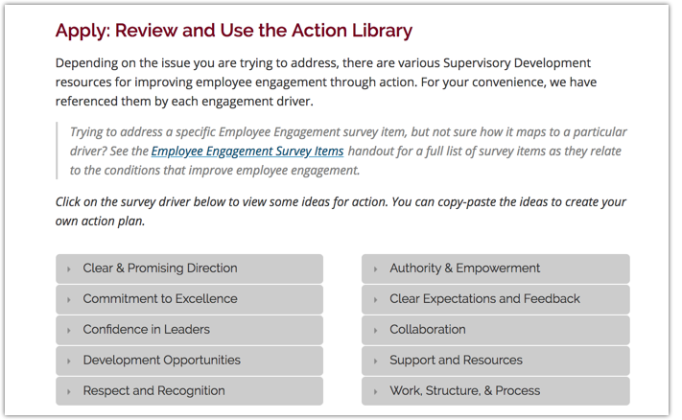
Action Library
Go to supervising.umn.edu > Module 5: Employee Engagement > EE Cycle: Action > Apply: Find and Use the Resources

Roles and Responsibilities Exercise

Explore the Quick Guide to Leading Teams – Clarifying Roles and Responsibilities exercise to gain a deeper understanding of the work that each person is doing.
Notes:

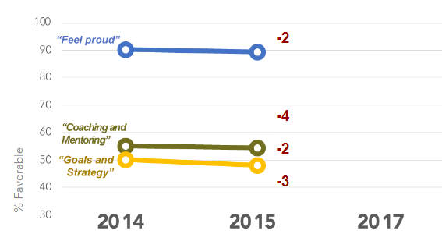
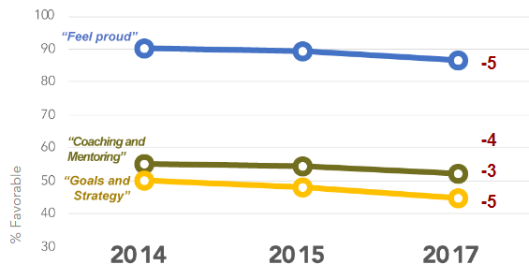
Take Action or Not?

Notes:

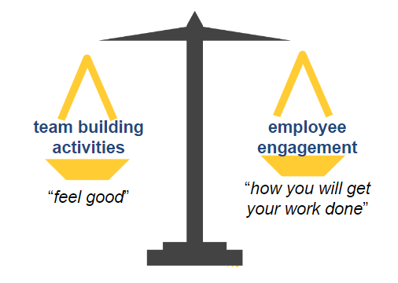
How do you want to invest your time?
Spending time and energy doing things to improve engagement is a cost. When you are thinking about a particular action, consider:
- What are the benefits of taking that action?
- Will it improve productivity?
- Will it help you retain talented people?
- Will it remove a source of frustration?

What’s ONE thing?
What’s one action you could integrate into your regular routine to foster employee engagement in your team or department?

Webinar Final Q&A
Notes:

Resources

Supervisory Development Course

Module 5: Employee Engagement

Action Library (scroll down to the bottom of the page)

Navigating your Report Data: ee.ltd.umn.edu (for supervisors with data from the Employee Engagement survey)
- Quick Guide to Employee Engagement
- Employee Engagement Cycle: Input
- Employee Engagement Cycle: Discussion
- Employee Engagement Drivers and Self-Reflection Questions
- Employee Engagement Drivers and Discussion Questions
Let LTD know how it’s going! Submit your questions/comments here: http://z.umn.edu/SDCaskUs

