The purpose of this ActionSheet is to reinforce what you learn about performance management. This actionsheet accompanies the live or recorded webinar, “Performance Management Reality Check.” Print or take notes electronically.

Why is Performance Management hard?
Reflect on the following.
- What is the most challenging part of performance management for you?

- _______________ is one of the main reasons why performance management feels ineffective.

What are Performance Management best practices?

True or False?

Writing and delivering a better performance review will help improve performance.

Label the performance management process: check-ins, evaluation, goal setting

_______________ _______________ _______________
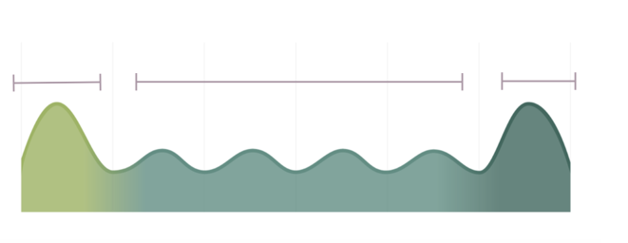

What works in Goal Setting?*

* For more information, see the Quick Guide to Goal Setting.

What works for check-ins?*

* For more information, see the Quick Guide to Ongoing Check-Ins.
- Overengineered goals can become _______________ in less time that it took to create them.
- While it’s common to focus on problem performance, it is crucial to remember to attend to _______________ because _______________.

What works in Performance Evaluations?*

* For more information, see the Quick Guide to Performance Evaluation.

Check your knowledge

The best practice is to have check-ins (pick one)

Weekly

Monthly

It doesn’t matter

What’s ONE thing?
What is one thing you can commit to doing to make your performance management experiences more effective?

Interview and Final Q&A
Notes:

Resources

Supervisory Development Course
- Module 2: Managing and Evaluating Performance
Where are the materials mentioned in the webinar?
Go to supervising.umn.edu, Module 2: Managing and Evaluating Performance.
Quick Guides:
- A Quick Guide to Goal Setting (PDF)
- Goal Setting Template (MS Word)
- A Quick Guide to Ongoing Check-Ins (PDF)
- Check-In Template (MS Word)
- A Quick Guide to Performance Evaluation (PDF)
- U of M Leadership Competency Model (PDF)
Videos:
- Effective Performance Management
- Managing and Evaluating Performance Webinar & Podcast (Recorded March 28, 2017)

Let LTD know how it’s going! Submit your questions/comments here: http://z.umn.edu/SDCaskUs

