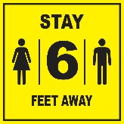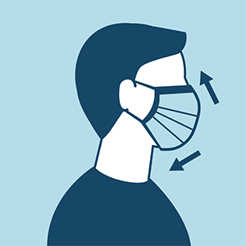

[Brief overview of job that clients are applying to or currently hold.]

* [Job responsibility 1]
* [Job responsibility 2]
* [Job responsibility 3]

**Who is [Employer Name]?**

[Brief description of company]

**What are the job responsibilities?**

[Job Title]

**What do I do if I think or know that I have COVID-19?**

[Use the response from survey question 4 to complete this section.]

**How can I prevent risk?**

* Wear a face mask in the workplace
* Wear gloves when in the field
* Wash your hands frequently/use hand sanitizer after touching surfaces
* Avoid touching your eyes, nose, and mouth
* Limit time socializing with other employees, maintain 6-foot distance when possible
* Do not eat or drink in the work area or around other people
* Avoid sharing personal items
* [Employer and job specific safety measures as appropriate]

**What are the safety protocols?**

* [Use the response from questions number 2 and 3 on the COVID-19 Employer Survey to complete this section.]
* [Use the response from questions number 5 and 6 as applicable.]

**[Employer Name]**

**Workplace Health & Safety during COVID-19**