The purpose of this ActionSheet is to reinforce what you learn about accountability. This ActionSheet accompanies the live or recorded webinar, “Driving Action through Accountability”. Print or take notes electronically.

Accountability

Fill in the blank:
Accountability means that there is a _________ (either positive or negative) if a person takes or doesn’t take an action.

The Accountability Ladder
The Accountability Ladder describes the hierarchy of consequences if someone achieves or doesn’t achieve an outcome. It’s intended to be illustrative, not comprehensive, and it provides benchmarks for the impact of different actions.

Fill in the different categories of consequences in the righthand column:
Level |  | Consequence | Consequence type
10 |  | They can be terminated or promoted for their action/lack of action |  | Enter consequence type…
9 |  | Their career progress and/or work opportunities accelerates or decelerates
8 |  | They receive meaningfully more or less compensation |  | Enter consequence type…
7 |  | They receive a higher or lower rating on their performance goals
6 |  | Many others know about their success/failure |  | Enter consequence type…
5 |  | They receive praise or critique from you, their supervisor
4 |  | They feel strong cultural pressure to do/not do something
3 |  | A few others know about their success/failure |  | Enter consequence type…
2 |  | Only they know about their success/failure
1 |  | Many others know what their responsibilities are
0 |  | There are no consequences for their actions |  | Enter consequence type…

Unpacking Key Accountabilities

Fill in the blank:
A Key Accountability needs to be either an _________ or _________, and it also needs to be specific and concrete enough so that it’s easier to hold someone accountable to it.

Reflect (after the webinar):
Think about your team. What’s a key accountability you would like to drive? Is it specific and an outcome or observable behavior? What is the current level of consequence on the Accountability ladder? Write it down below.

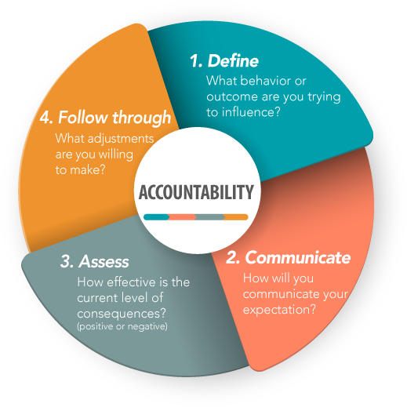
Steps to Drive Action through Accountability
- Define the Accountability
- Communicate your expectations and make sure the employee understands
- Assess the current level of consequences
- Follow through and make adjustments

Why is this difficult?

Reflect (after the webinar):
Think about a key accountability on your team that’s currently at a 3, “a few others know about their success or failure”.
Think about what you would feel like if you HAD to go from a 3 to a 5, right now. What would that first conversation be like? What would you need to explain? How comfortable would you be having this conversation?
After the webinar, return here to write your ideas about what gets in your way.

What Can You Do?

Be Clear ● Share Information ● Give Support ● Provide Freedom ● Provide Resources

Reflect on the questions below:
Are you clear about the goal, responsibility, and consequences of action or inaction? Who else is involved and what outcomes are expected?

How do you or others on your team share the information? Employees need access to all the information needed to make decisions.

What are you doing to provide support? How do you allow for mistakes and learning opportunities?

What freedom do people on the team have to direct important aspects of the work?

How can you streamline the processes and cut through red tape?

Q&A
Notes:

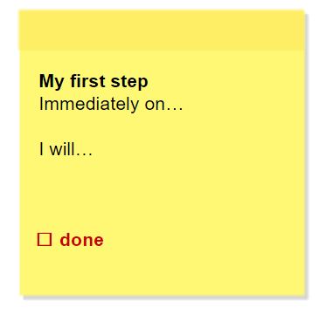
Reflection + Action
What can you realize and achieve based on what you’ve learned?
How will you implement it?
What will your first step be?

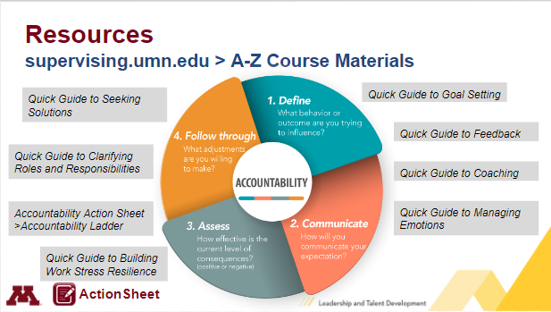
Resources
Where are the materials mentioned in the webinar? Find these and other resources at supervising.umn.edu/z-course-materials
- Define
- Quick Guide to Goal Setting
- Quick Guide to Feedback
- Communicate
- Quick Guide to Coaching
- Quick Guide to Managing Emotions
- Asses
- Quick Guide to Building Work Stress Resilience
- Follow through
- Quick Guide to Clarifying Roles and Responsibilities
- Quick Guide to Seeking Solutions
Let LTD know how it’s going! Submit your questions/comments here: http://z.umn.edu/SDCaskUs

