The purpose of this ActionSheet is to reinforce what you learn about preparing for and managing flexible teams. This ActionSheet accompanies the, “Managing Flexible Teams” webinar. Feel free to print or take notes electronically.

Part 1: What are Flexible Work Arrangements (FWAs)?

Benefits of flexible teams
As you listen to the webinar, record your thoughts on the benefits of flexible teams. Challenge yourself to think critically about how and where the work needs to get done.
How might your team benefit from more flexibility?

Expectations for supervisors
Follow along with the conversation and take notes about the changing expectations for supervisors:

Part 2: How do I Prepare for Flexible Work?
For the best learning experience, pause the webinar and reflect after each step. Alternatively, you can download the Preparing for Flexible Work Arrangements worksheet and reflect after viewing the webinar.

Check with local leaders

Self-reflection questions
Pause the webinar and reflect on the following questions:
- What is my campus, college, or unit’s guidance on flexible work arrangements?

- What departmental support can I expect for my team?

- What kind of space will be available to my team if some still work in-person full time or part time?

- What specific guidance is there for different employee groups I supervise (labor represented, civil service, P&A, faculty, etc.)?

Understand Your Bias
Here are common types of bias that can show up in working with flexibility:
- Affinity bias is when you give preferential treatment to someone because they share similar experiences as you or remind you of someone you know and like.
- Recency bias is when recent events or information are given more weight and importance than older ones.
- Confirmation bias is seeking or taking in new information to confirm your own beliefs.
- Consensus bias is when people see their own thoughts, choices, and judgements as common and shared with others.

Self-reflection questions
Pause the webinar and reflect on the following:
- How will I make sure affinity bias is not affecting my decisions? Is how much I like a person driving any of my decisions (e.g., decisions around flexibility, recognition, challenging assignments, etc.)?

- How will I make sure recency bias isn’t affecting how I treat the people on my team? How can I make sure everyone stays on the same page and that more recent information isn’t being given more importance than older information?

- How does confirmation bias affect the way I think and make decisions? What information contradicts my beliefs?

Commit to Equity
Follow along with the conversation and take notes about how to think about equity and bias in flexible work:

After the conversation, pause the webinar and reflect on the following questions:
- What kind of flexibility can I offer the people I supervise whose position doesn’t afford them flexibility around space? How can I get curious and creative about improving their working arrangement?

- How will I reward and recognize the people I supervise? What will I be basing my decisions on? How will I make sure that I don’t fall into rewarding only the people I see most often (in-person or online)?

- How will I manage the workload of team members so that it is distributed equitably? How can I invite employee input on workload distribution? How will I make sure meaningful work and opportunities are distributed equitably regardless of an individual’s work arrangement?

- How might flexibility around the work help me better recruit people with disabilities or different living circumstances?

Step 1. Analyze the nature of the work

Self-reflection questions
Pause the webinar and reflect on the nature of the team’s collective work:
- What is the team responsible for and what parts of the team’s work must be done in-person?

- What parts of the team’s work can be done virtually?

- What parts of the team’s work has always been done in-person? Why? Can I challenge my beliefs about the work and think about how things can be done in different ways?

Then consider the nature of the position’s work. Do this for each position on your team.
- What parts of this position’s work and responsibilities must be done in-person?

- What parts of this position’s work can be done virtually?

- What parts of the position’s work has always been done in-person? Why? Can I challenge my beliefs about this position’s work and think about how things can be done in different ways?

- What kind of flexibility can I offer this position, based on the nature of its work and responsibilities?

If you’re unsure of the nature of the other person’s work, have a discussion with them.
- What drives productivity in your role? (E.g., focus, coordination, collaboration, etc.) What helps you accomplish your highest-impact responsibilities?

- What parts of your responsibilities do you think you need to be in-person to accomplish? What can be done virtually?

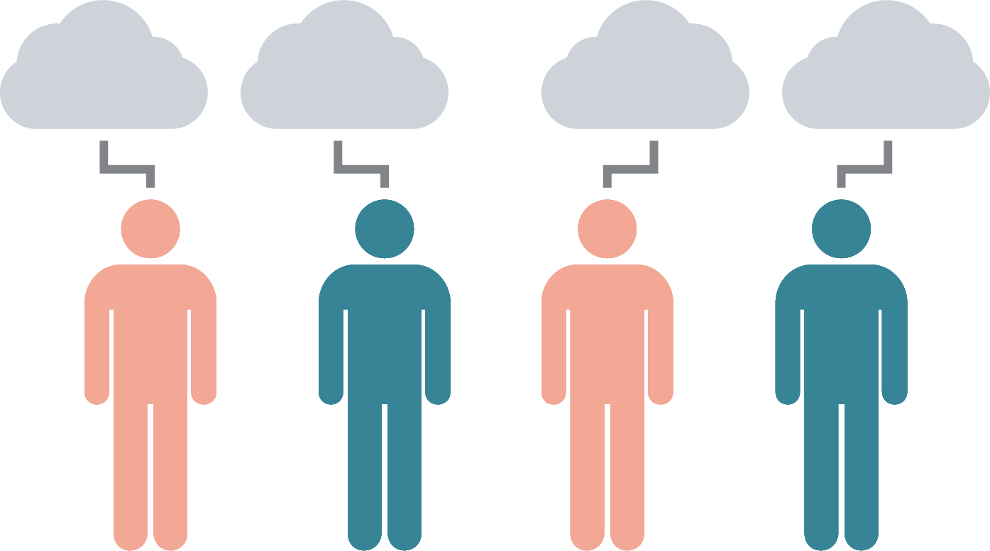
Step 2. Understand Individual Preferences

Self-reflection questions
Pause the webinar and reflect on the following:
- Given the flexibility their position can have, what are their preferences?

- What concerns do they have about working with flexibility? What are they excited about? How can I help and support them?

- What level of time, energy, and support do I need to manage the work of a flexible team?

- What will business and non-business hours look like for the entire team? How do I make sure everyone is on the same page?

- How might I use flexibility to attract diverse applicants for future positions on my team?

- How will I onboard a new employee the next time I hire? What will that look like?

Step 3. Plan to Revisit and Re-evaluate

Self-reflection questions
Pause the webinar and reflect on the following:
- How will I keep track of how working with flexibility is going with the employee? How often will I check-in?

- How will I hold myself accountable to checking-in with them to find out what is and is not working?

- How can I make sure the voices of the people I supervise are being heard? How will I communicate to them that I’m acting on their feedback?

- How will I give feedback if our shared expectations about the work arrangements aren’t being met?

Part 3: How do I Successfully Manage Flexible Teams?

Define purpose, describe success
Pause the webinar and assess how well your team understands their purpose and what success looks like:
Team members understand our purpose and goals. | ☐ Agree | ☐ Disagree
Team members know why our work is important. | ☐ Agree | ☐ Disagree
Team members are pursuing the same agenda. | ☐ Agree | ☐ Disagree
If you answered disagree to any of these items, or if you want a deeper dive, review the Quick Guide to Defining a Clear Purpose for Team Success.
From the Quick Guide, what’s one thing you can commit to doing to define a clear purpose for your team? How will you hold yourself accountable? Type your answer below.

Clarify roles & responsibilities
Pause the webinar and assess your team’s clarity on roles and responsibilities:
I rarely have to set aside important work to deal with unnecessary tasks. | ☐ Agree | ☐ Disagree
I rarely have to disappoint one person to meet another person's expectations. | ☐ Agree | ☐ Disagree
I rarely receive requests that contradict each other. | ☐ Agree | ☐ Disagree
I know exactly what I need to do to succeed in my current role. | ☐ Agree | ☐ Disagree
If I don't have enough time to get everything done, I know which projects can wait. | ☐ Agree | ☐ Disagree
There are clear lines between my responsibilities and the responsibilities of others on my team. | ☐ Agree | ☐ Disagree
If you answered disagree to any of these items, or if you want a deeper dive, review the Quick Guide to Clarifying Roles and Responsibilities.
From the Quick Guide, what’s one thing you can commit to doing to clarify roles and responsibilities for your team? How will you hold yourself accountable? Answer below.

Establish norms that foster psychological safety
Pause the webinar and assess how well your team’s norms and psychological safety:
Team members are honest with each other. | ☐ Agree | ☐ Disagree
I know I can count on the other members of my team. | ☐ Agree | ☐ Disagree
Team members have confidence in each others' abilities. | ☐ Agree | ☐ Disagree
Team members are always willing to help each other out. | ☐ Agree | ☐ Disagree
Team members care about each other's emotional wellbeing. | ☐ Agree | ☐ Disagree
I listen carefully when others are speaking. | ☐ Agree | ☐ Disagree
Team members carefully when others are speaking. | ☐ Agree | ☐ Disagree
I respect what others have to say. | ☐ Agree | ☐ Disagree
Team members what others have to say. | ☐ Agree | ☐ Disagree
I ask team members for their thoughts and concerns. | ☐ Agree | ☐ Disagree
Team members want to hear others' thoughts and concerns. | ☐ Agree | ☐ Disagree
If you answered disagree to any of these items, or if you want a deeper dive, review the Quick Guide to Establishing Norms and Expectations.
From the Quick Guide, what’s one thing you can commit to doing to establish norms and expectations for your flexible team? How will you hold yourself accountable? Answer below.

Revisit Communication Norms
Pause the webinar and your team’s communication:
Our team communicates frequently and freely about the work. | ☐ Agree | ☐ Disagree
Team members have an understand of how others prefer to ask questions. | ☐ Agree | ☐ Disagree
Team members freely reach out with questions, ideas, and support. | ☐ Agree | ☐ Disagree

If you answered disagree to any of these items, think about how you can set expectations around communication. Review the table below and think through what communication method makes sense for each issue. After giving it some thought, clarify these communication expectations with your team members.

 | Chat | Email | Phone | Zoom | Collaboration tools

Update and inform

Gather input

1:1 ongoing check-ins

Team check-ins

Collaborate

Address & manage conflict

What kind of norms help flexible teams?
Follow along and take notes about what kind of norms you can establish on your team:

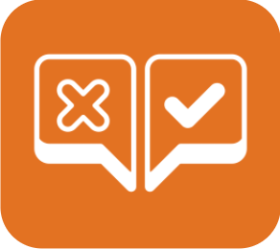
Establish clear decision-making processes
Pause the webinar and assess the effectiveness of your team’s decision-making processes:
Our team is on the same page about how to make important decisions. | ☐ Agree | ☐ Disagree
Our team usually agrees about how much time to spend discussing each issue. | ☐ Agree | ☐ Disagree
Our team rarely disagrees about the best way to make a decision. | ☐ Agree | ☐ Disagree
If you answered disagree to any of these items, or if you want a deeper dive, review the Quick Guide to Establishing Clear Decision-Making Processes.
From the Quick Guide, what’s one thing you can commit to doing to establish clear decision-making processes for your flexible team? How will you hold yourself accountable? Answer below.

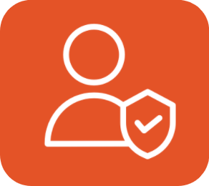
Foster Accountability
Pause the webinar and assess the degree of accountability on your team:
Team members know what results are expected of them and how to achieve them. | ☐ Agree | ☐ Disagree
There are relevant metrics or perfromance indicators to assess progress. | ☐ Agree | ☐ Disagree
When progress isn’t being made on the work, consequences are communicated to team members. | ☐ Agree | ☐ Disagree
If you answered disagree to any of these items, or if you want a deeper dive, review the Quick Guide to Establishing a Culture of Accountability.
From the materials, what’s one thing you can commit to doing to foster a culture of accountability on your team? How will you hold yourself accountable? Answer below.

Manage team conflict
Pause the webinar and assess the level of conflict on your team:
Team members are candid with one another. | ☐ Agree | ☐ Disagree
Team members speak up if they disagree about a course of action. | ☐ Agree | ☐ Disagree
Team members do not hesitate to challenge one another's ideas if they disagree. | ☐ Agree | ☐ Disagree
Team members get along with each other. | ☐ Agree | ☐ Disagree
Disagreement over work rarely gets emotional on our team. | ☐ Agree | ☐ Disagree
On our team, disagreements are rarely taken personally. | ☐ Agree | ☐ Disagree
Members of the team rarely make changes to work without informing others. | ☐ Agree | ☐ Disagree
Members of the team rarely miss important deadlines. | ☐ Agree | ☐ Disagree
Members of the team rarely try to take control of the team's work. | ☐ Agree | ☐ Disagree
If you answered disagree to any of these items, or if you want a deeper dive, review the supervisory development resources on assessing the sources of conflict and mastering conflict management skills.
From the materials, what’s one thing you can commit to doing to prevent and manage conflict for your team? How will you hold yourself accountable? Answer below.

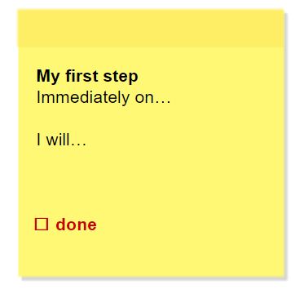
Reflection + Action
What can you realize and achieve based on what you’ve learned?
How will you implement it?
What will your first step be?

Resources
Explore the module on Leading Teams and the University’s Work. With Flexibility. website.
Where are the materials mentioned in the webinar? Find these and other resources at supervising.umn.edu/z-course-materials
- A Quick Guide to Preparing for Flexible Work Arrangements (MS Word)
- A Quick Guide to Managing Flexible Teams (PDF)
- A Flexible Work Arrangement Discussion Guide (PDF)
- Defining a Clear Purpose for Team Success (PDF)
- Clarifying Roles and Responsibilities (PDF)
- Establishing Norms and Expectations (PDF)
- Establishing Clear Decision-Making Processes (PDF)
- Assessing the Source of Conflict (PDF)
- Mastering Conflict Management Skills (Webpage)
Looking for collaboration or virtual teams tools?
- Slack – Create a virtual workspace for easy collaboration.
- Asana – Project tracking.
- Google Chat – Quick chat tool built right into your inbox.
- Zoom – Web conferencing for 1:1s and team meetings.
- G Suite Apps – Document collaboration.
Let LTD know how it’s going! Submit your questions/comments here: http://z.umn.edu/SDCaskUs

